**FINAL PROJECT REPORT**

**FutureGenius LMS**

**Project Supervisor**

**Mr. Abdullah Qamar**

**Submitted By**

**Group ID: S25PROJECT706CE**

**Ambreen Bibi – BC200409484**

**Software Projects & Research Section**

**Department of Computer Sciences**

**Virtual University of Pakistan**

**CERTIFICATE**

This is to certify that Ambreen Bibi (BC200409484) has worked on and completed the Software Project at the Software & Research Projects Section,   
Department of Computer Sciences, Virtual University of Pakistan, in partial fulfillment of the requirement for the degree of BS in Computer Sciences   
under my guidance and supervision.  
  
In my opinion, the project is satisfactory and up to the mark and therefore fulfills the requirements of BS in Computer Sciences.

Supervisor / Internal Examiner:  
Mr. Abdullah Qamar  
  
Signature: ___________________

External Examiner:  
___________________ (Name)  
  
Signature: ___________________

Accepted By:  
_____________ (For Office Use)

**CHAPTER 1  
Gathering & Analyzing Info**

## .1 Introduction

Kidicode is a web-based Learning Management System (LMS) designed for kids learning STEM and AI coding in Pakistan. The system supports online classes, in-person sessions, and self-paced learning through an interactive platform. It provides separate dashboards for admins, instructors, students, and parents. The project focuses on delivering an engaging, secure, and user-friendly environment using modern web technologies. It aims to enhance learning with quizzes, gamification, and progress-tracking tools

.**Scope of the Project**

The project encompasses the design, development, deployment, and testing of a comprehensive LMS web application. It includes distinct modules for students, instructors, parents, and administrators. The system is intended to centralize and streamline the learning process while promoting engagement through gamification, progress tracking, and interactive content.

**Functional Requirements**

**🔹 1. User Authentication & Role Management**

* Users can register and log in using email, phone number, or social media (e.g., Google/Facebook).
* Role-based access:
  + **Admin**: Full access to system settings, users, courses, analytics.
  + **Instructor**: Manage course content, view student progress, assign quizzes.
  + **Student**: Enroll in courses, access learning content, take quizzes, track progress.
  + **Parent**: Monitor child’s course progress, view reports.

**🔹 2. Course Management**

* Admins/Instructors can:
  + Create, edit, delete courses.
  + Assign courses to students.
  + Set difficulty levels: Beginner, Intermediate, Advanced.
  + Add lessons in text, video, or interactive formats.

**🔹 3. Learning Content & Interaction**

* Students can:
  + Access lessons (text, video, PDF).
  + Take quizzes (MCQs, coding exercises, short answer).
  + Submit assignments.
  + View progress and achievements.

**🔹 4. Gamification Features**

* Award points, badges, and ranks based on activity and quiz performance.
* Maintain leaderboards to boost competition and engagement.

**🔹 5. SCORM/xAPI Integration**

* Support for SCORM or xAPI packages for tracking learner experiences and compliance with e-learning standards.

**🔹 6. Parent Portal**

* Parents can:
  + View child’s course enrollments and performance.
  + Receive notifications on progress or issues.
  + Access reports and feedback from instructors.

**🔹 7. Payment and Subscription System**

* Users can:
  + Browse free and paid courses.
  + Subscribe to Monthly or Yearly plans.
  + Make payments via integrated gateway (Stripe, PayPal, or local providers).



**📌 Non-Functional Requirements**

**🔹 1. Performance Requirements**

* The system must load any page within **2 seconds** under normal conditions.
* The LMS should support at least **500 concurrent users** without crashing.

**🔹 2. Scalability**

* The system should be able to scale vertically (more power) or horizontally (more servers) to support more users and data in the future.

**🔹 3. Security**

* Passwords should be stored using hashing (e.g., bcrypt).
* Use HTTPS for secure data transmission.
* Implement role-based access control.
* Prevent common attacks (SQL injection, XSS, CSRF).
* Secure payment integration using PCI-DSS compliant services.

**🔹 4. Usability**

* The interface should be clean, responsive, and mobile-friendly.
* Target age group (kids, parents) should find the UI intuitive.
* Provide helpful tooltips, onboarding, and accessibility support.

**🔹 5. Maintainability**

* The code should be modular and well-documented.
* Use GitHub for version control and team collaboration.
* Follow MVC pattern (Laravel) for easy maintenance.

**🔹 6. Availability**

* The system should be available **99.5% of the time**.

**Use Case Diagram**



**Use Case Scenarios**

* Register/Login - Authenticates users via email, phone, or social login
* Manage User Roles - Admin assigns and updates user roles
* Create/Edit Courses - Enables creating, editing, or deleting a course
* View Course Content - Allows students to view course lessons
* Submit Assignments - Students can upload files or write answers
* View Progress - Shows badges, quiz scores, and progress bar
* Generate Reports - Creates report on performance and activity
* Assign Badges & Points - Awards based on actions and performance
* View Child Progress - Displays enrolled courses and progress
* Make Payment / Subscribe - Enables secure course subscriptions

**Adopted Methodology: VU Process Model**

For the development of the FutureGenius LMS, we adopted the VU Process Model, a hybrid approach combining the Waterfall and Spiral models.

**Why VU Process Model?**

* Break the project into manageable phases with clearly defined deliverables.
* Incorporate customer/stakeholder feedback at regular intervals.
* Ensure thorough documentation and systematic development.
* Reduce risks through early prototyping and analysis.
* Maintain flexibility by enabling iteration where needed, while still following a structured sequence.

**Phases of VU Process Model Adopted**

* Communication – Requirements gathering from the client.
* Planning – Project scheduling, defining milestones, and resource allocation.
* Risk Analysis – Identified risks like delayed feedback, cloud deployment issues.
* Engineering (Design & Development) – UI/UX design and backend structure.
* Prototyping (Spiral) – Intermediate dashboards shown for feedback.
* Testing – Unit, integration, and user acceptance testing.
* Deployment – Application deployed to the cloud.
* Maintenance – Basic support documented for post-deployment issues.

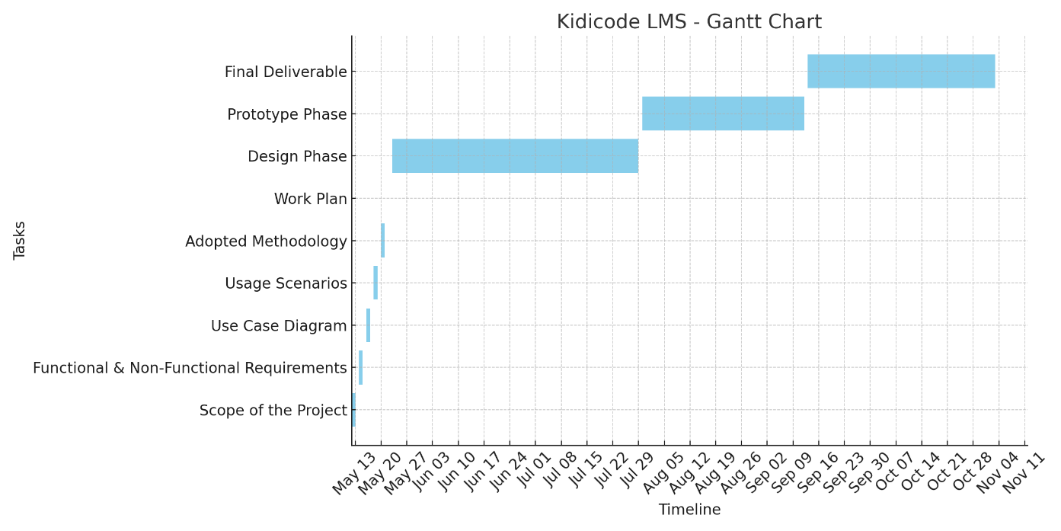

## CHAPTER 2 .1 Introduction

Kidicode is a web-based Learning Management System (LMS) designed for kids learning STEM and AI coding in Pakistan. The system supports online classes, in-person sessions, and self-paced learning through an interactive platform. It provides separate dashboards for admins, instructors, students, and parents.

**CHAPTER 2  
Designing the Project**

## CHAPTER 2 .1 Introduction

Kidicode is a web-based Learning Management System (LMS) designed for kids learning STEM and AI coding in Pakistan. The system supports online classes, in-person sessions, and self-paced learning through an interactive platform. It provides separate dashboards for admins, instructors, students, and parents

**2.2 Purpose**

The purpose of this project is to develop a complete LMS that helps manage courses, users, assessments, and learning activities efficiently. It aims to provide interactive learning experiences for students and an easy-to-use platform for instructors and parents. The system integrates gamification and SCORM/xAPI tracking to improve engagement and monitor progress. It also supports paid and free courses with secure payment processing. Ultimately, the goal is to create a professional educational system suitable for real-world deployment.

**2.3 Scope**

The scope includes designing and implementing a web application with dashboards for Admin, Instructor, Student, and Parent roles. Core features include authentication, course creation, quizzes, assignments, progress tracking, and gamified learning. The system will support subscription plans, payment gateways, and SCORM/xAPI compatibility.

**2.4 Definitions, Acronyms and Abbreviations**

This section explains key terms and abbreviations used in the project. LMS refers to a Learning Management System used to deliver and track online learning. SCORM and xAPI are e-learning standards used for recording learning experiences. API stands for Application Programming Interface used for backend communication. Additional terms include MVC (Model-View-Controller), CRUD (Create, Read, Update, Delete), and UI/UX (user interface and user experience)

Entity Relationship Diagram (ERD)

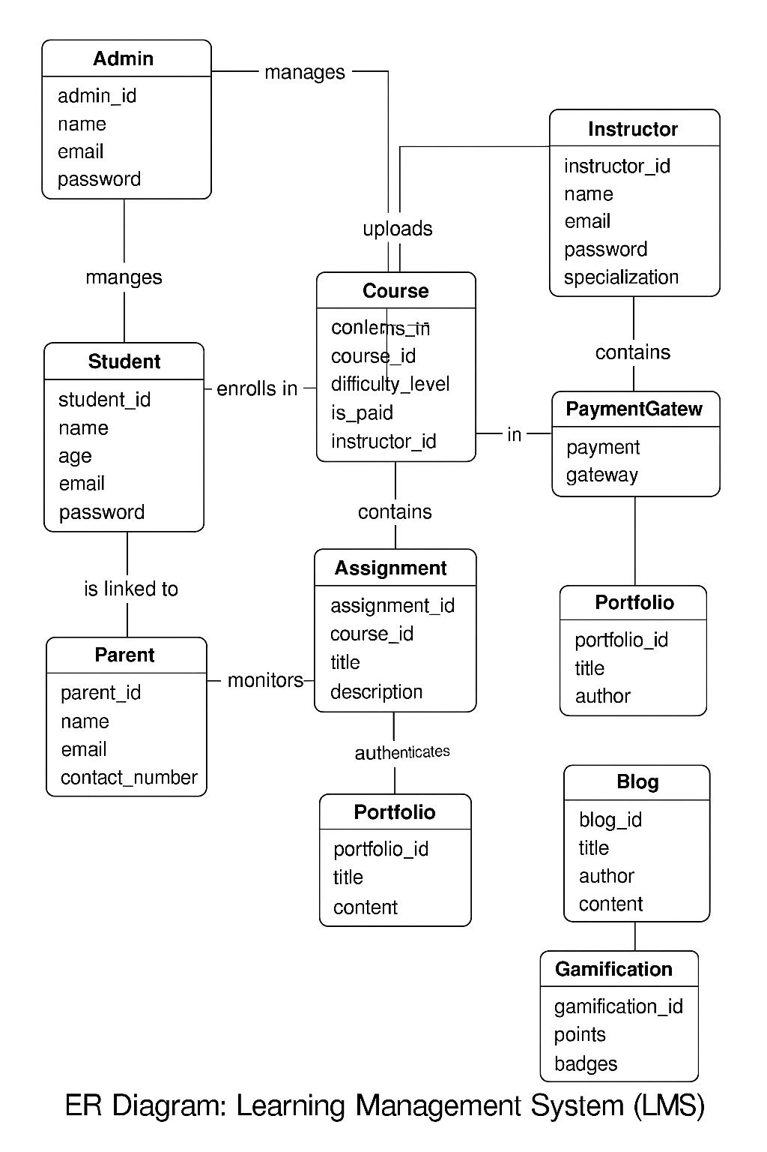

Sequence Diagrams

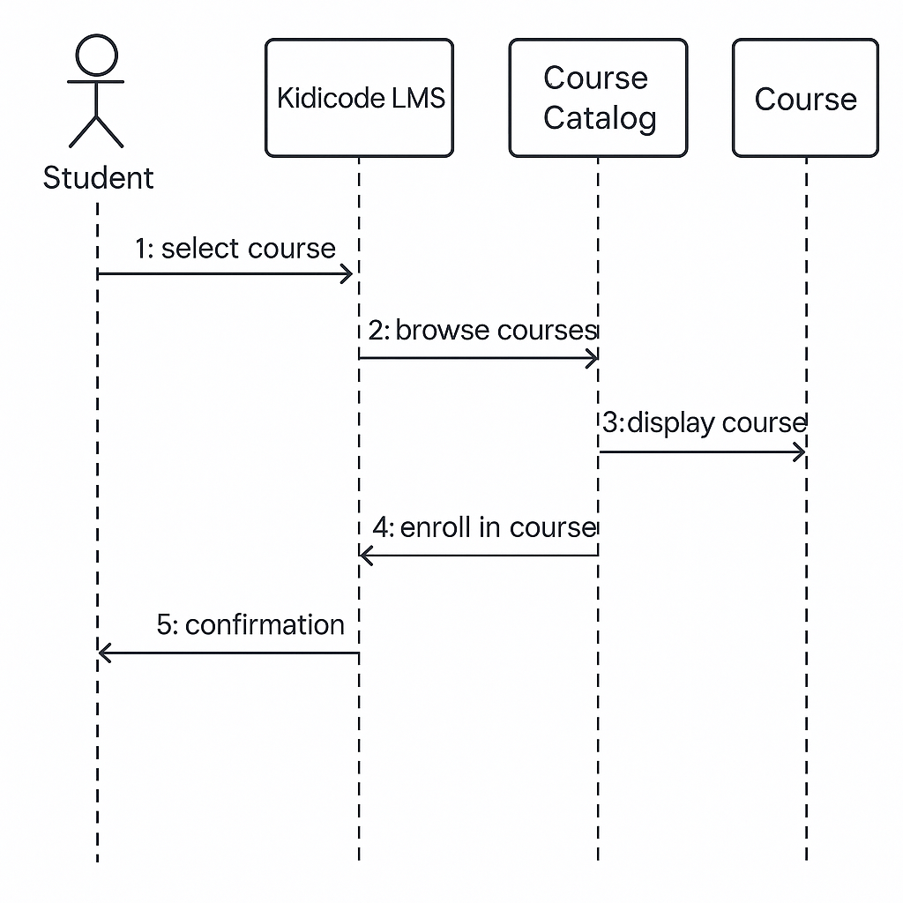

1. Architecture Design Diagram

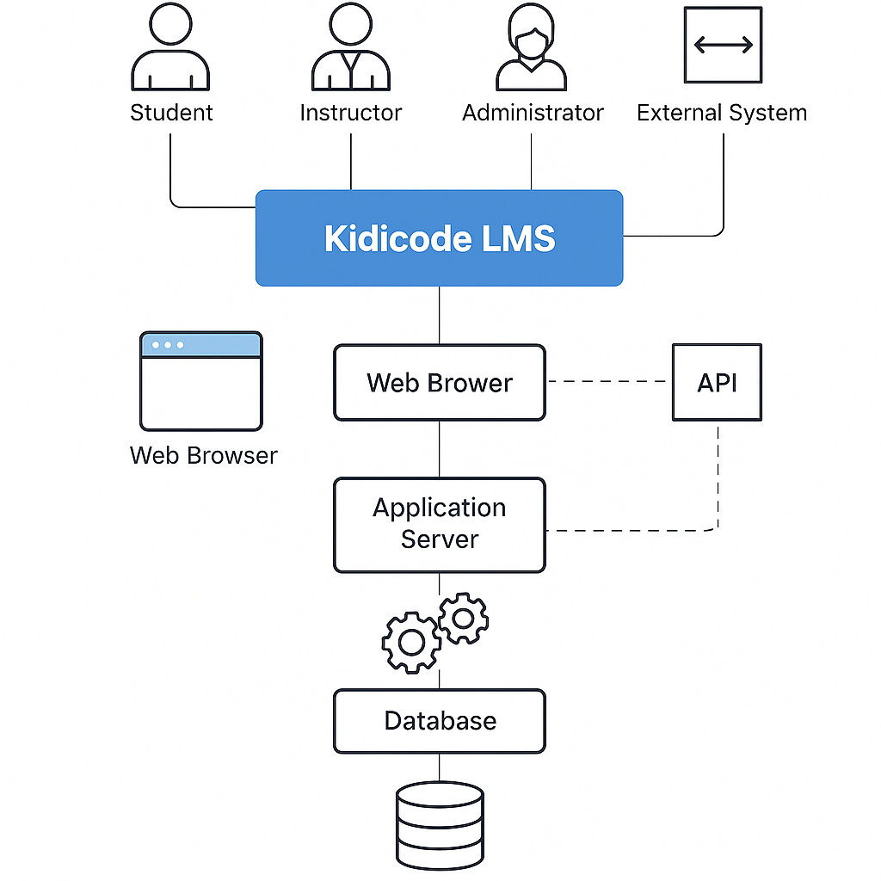

CLASS DIAGRAM

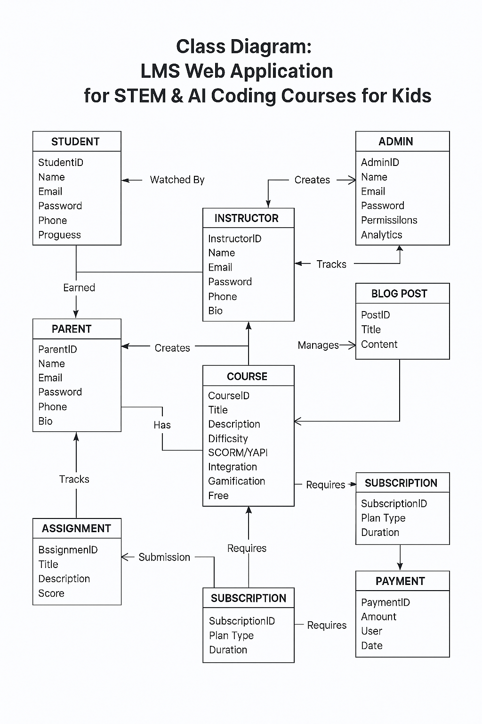

Database design 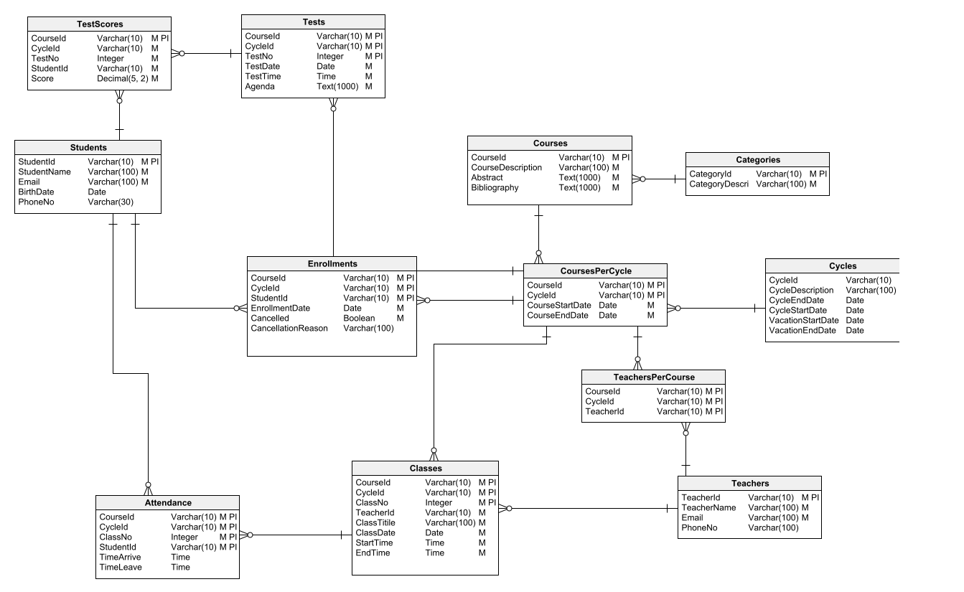

**CHAPTER 3  
Development**

## ****REFERENCES****

The references for this project include online research articles, LMS documentation, and official developer guides. Key sources used were Laravel documentation, JavaScript framework documentation (React/Vue/Angular), and SCORM/xAPI standard.

## ****APPENDIX****

The appendix contains supporting materials that complement the main report. This includes diagrams such as the ERD, Sequence Diagrams, Architecture Diagram, Use Case Diagram, and Database Design. It may also include sample screenshots of interfaces, test cases, and code snippets. Any supplementary documents, tables, or research data used during development are also included here. The appendix provides additional clarity but is not part of the main discussion.